FOR IMMEDIATE RELEASE

For more information,
contact: Tyler Johnson
Expanded Food and Nutrition Education Program Agent, Wildcat Extension District
tajohnson120@ksu.edu, 620-232-1930

Healthy Eating During the Holidays
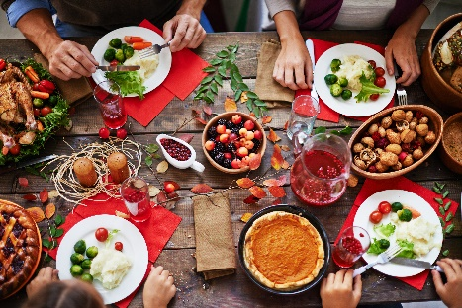

The holidays are a time of family, friends, and food. At the same time, many of us unknowingly eat a few days’ worth of calories in one sitting. There are a number of tips and tricks you can use to keep the dreaded holiday weight gain from happening. They can be done at different times centered around the meal too. That way if you do not remember, you can still make your holidays healthier.

Before the Meal
Image Source: Simply Sorghum

Do not skip a meal to “prepare for later.” By eating a meal, especially breakfast, you will jumpstart your metabolism helping you digest your food better. Also, if you already have food in your system, you are less likely to over eat.

Limit the taste-testing. This is a hard one, especially for kitchen helpers. Taste testing tiny bites is sometimes necessary for cooking, but a tiny bit should be all. Try to cook when you are not hungry. Remember holiday dishes are usually full of calories. Calories in small bites can add up quickly.

Modify your recipes. Change the way you make some favorite recipes to make them healthier. Keep in mind they will not taste exactly the same, but they will taste close.

Bring a healthy dish with you. My Holiday meals are usually potlucks to some degree. When this is the case, if you bring a healthy dish, you know there will be something available that fits in with your healthy eating plan.

During the Meal
- Start with vegetables. Just like many meals, starting a holiday meal with a salad, steamed vegetables, or some sort of vegetable dish will get rid of some of your hunger. Plus, vegetables are high in a fiber which will help with pacing a digestion for the rest of the meal.
- Eat slowly. Enjoy the time with your friends and family. Talk, laugh, and make it a longer meal time. Eating fast, especially in during the holidays does a number of things. It does not give our bodies enough time to start digesting the food. This causes us to eat more before our body realizes it is full. Secondly, eating quickly sometimes leads to not chewing your food enough. This can lead to a number of uncomfortable issues after the meal. Finally, you swallow a lot of air when you eat fast. This causes bloating.
- Make your servings smaller. Holiday meals are usually times when the “favorite foods” we do not see the rest of the year come out. Instead of eating a lot of your favorite foods because they are available and paying for it later, just take a little of each dish. That way you can sample all of your favorites and still not feel too full to enjoy a small piece of your favorite pie after the meal.
- Drink plenty of room temperature water. Drinking cold water shocks your body. Your body is going to be working hard to digest the meal, so you do not want to sock it. Room temperature water will keep help you stay hydrated without the shock and will help you feel fuller faster.

After the Meal
- Walk. Exercise is good anytime. After a holiday meal you might think it is not a good idea. By walking after you eat, it will help with digestion, increase your metabolism, help maintain blood sugar levels, help the blood flow throughout the body, and help you maintain your weight

Please contact me to schedule an appointment or for more information, contact Tyler Johnson, tajohnson120@ksu.edu, or by calling 620-232-1930.

# # #

K - State Research and Extension is an equal opportunity provider and employer

